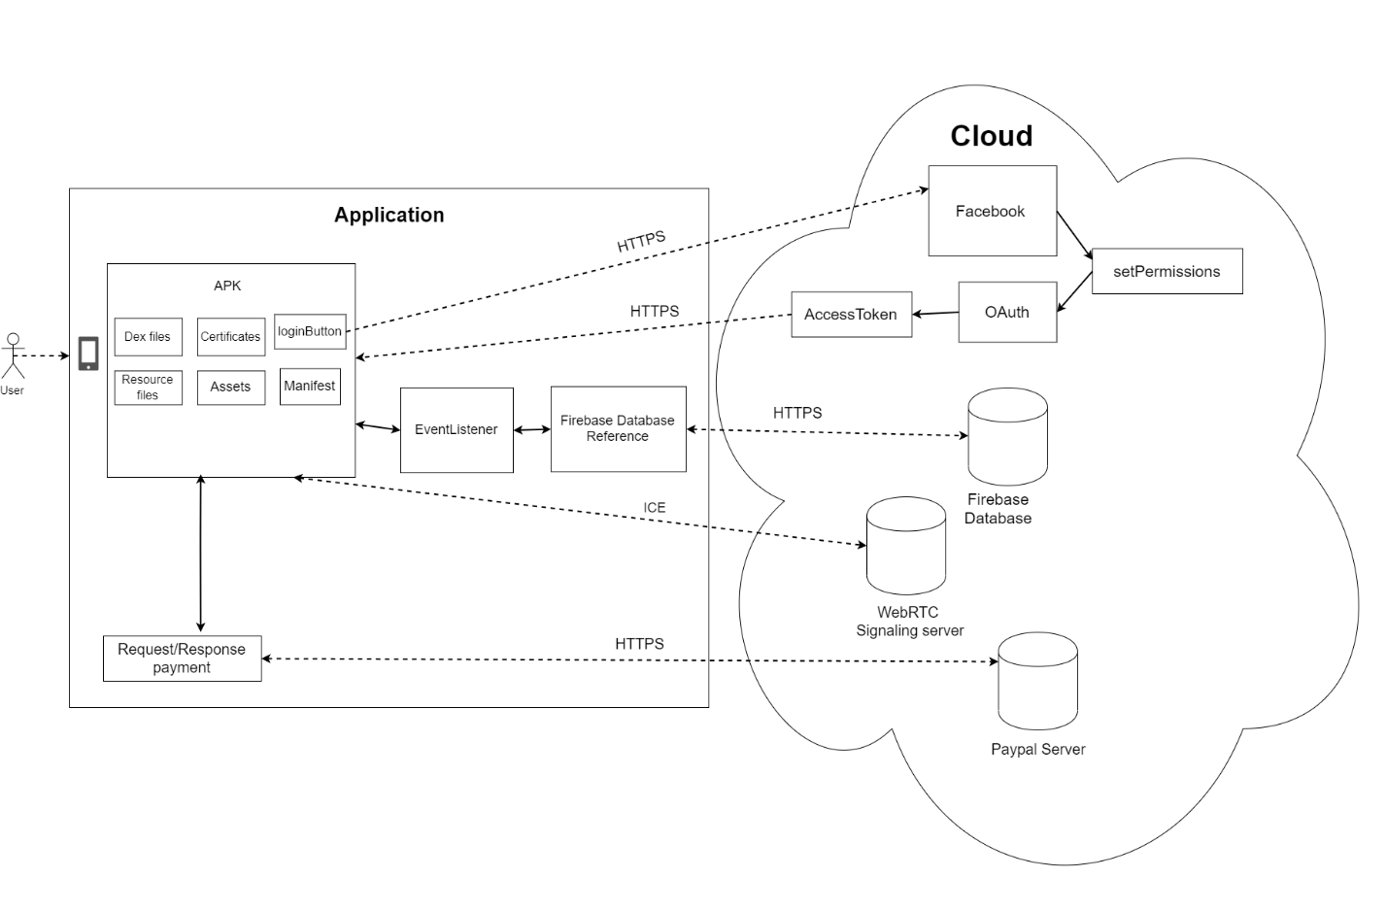

The above diagram shows what are the application’s components, how the application communicates with each component and what runs on the application and what on the cloud. It shows the basic software structure.

As we can see, a user by installing the application from google play store, the application’s APK (Android Package) file is installed on his/her android device. An APK file is a container folder of all the compiled parts of the android application. Typically the parts are: Dex files, Certificates, Resource files, Assets and Manifest file.

One of the functionalities of the application is for the user to be able to register using his/her Facebook account. So a component would be connecting with Facebook. Facebook provides an API (Application Program Interface) that would make logging in to your app easier for the user. When a user presses the “Connect with Facebook” button, he/she is redirected to facebook.com where he/she is prompted to login to his/her Facebook account. Once logged in, a dialog box appears where the application’s icon and information is shown as well as what personal data will the application use. If a user decides to press “Continue”, Facebook grants permissions to the application to use the specific user data the application has asked for as well as an OAuth code. The OAuth code is an authorization code, where the application uses to send back to Facebook in order for Facebook to verify the identity of the application. After the identity has been confirmed, Facebook sends an Access Token back to the application that would be used in order for the application to gain access to certain user information such as email and profile picture.

Now in order to store the user’s data or any data that needs persistent state, google firebase real-time database is used. Firebase is a cloud based databased by google that lets the application store and sync data between users in real time. When a user registers or signs in with Facebook, a function is used called “signInWithCredential” were the credentials of the user (email and password) are safely stored on firebase. In order to store any other type of data on firebase, listeners are used. Listeners are triggered when data is changed in order to update the data in the database. A database reference represents a specific location in the database and is used to read and write data. Database reference used with Listeners allow the application just that, to read and write data.

Another component used by the application is WebRTC. WebRTC is an open project that provides browsers and applications real time communications via an API. In order for two peers (users) to communicate with each other, information about each other must be provided to each. An interactive connectivity establishment is a protocol used for connecting peer to peer. A signaling server running on the cloud is needed in order to coordinate communication, the exchange of information mentioned before.

In order for the user to make an in-app purchase, Paypal API is used. Once a user decides to pay for a tutor, a Paypal prompt will appear that would allow the user to log in to his/her paypal account or pay as guest. The information of the user’s credit/debit cart goes through the payment gateway where they would be encrypted and send to the payment processor. The payment processor sends a request to the user’s issuing bank to check if he/she has enough credit. The bank responds with a yes or no. If yes then the payment would go through and the user would have access to whatever he/she paid for.

**References:**

<https://en.wikipedia.org/wiki/Android_application_package>

<https://www.scienceabc.com/innovation/oauth-how-does-login-with-facebook-google-work.html>

<https://www.learnhowtoprogram.com/android/data-persistence/firebase-reading-data-and-event-listeners>

<https://www.html5rocks.com/en/tutorials/webrtc/infrastructure/>

<https://www.paypal.com/us/brc/article/how-online-payments-processing-works>